StudyCircle — Design Package
Capstone Project Artifact
FOR EXAMPLE PURPOSES ONLY. These design materials are for a sample project (StudyCircle). Each team should review and assess every section for applicability, design for its own requirements, and consider items this example does not include. Examples: a test plan (unit, integration, end-to-end, acceptance, accessibility); a threat model; a data dictionary and data-retention plan; UX research notes and personas; sequence diagrams for other critical flows; an OpenAPI file in the repo; a cost estimate for cloud and AI usage; and for R&D projects a research plan, experiment design, dataset description, model card, or hardware bill of materials instead of wireframes and an ERD.
StudyCircle is a single-page web app served from one Ubuntu VM on OpenStack: Nginx serves the client and proxies to a Node.js REST API, which owns all access to MariaDB, CAS and the OpenAI API. The browser never talks to the database, CAS ticket validation or OpenAI directly.

1. Technology choices
Layer | Choice | Why
Browser client | React 18 + TypeScript, Vite, React Router, TanStack Query | Common, well documented, easy for mixed-experience teams
UI components | Accessible component library (e.g., Radix-based) + CSS modules | Keyboard and screen-reader support out of the box
API | Node.js 20 LTS, Express, TypeScript, Zod validation | One language across client and server
Data access | Prisma ORM with the MySQL provider (MariaDB compatible), versioned migrations | Schema in code; migrations run in CI/CD
Database | MariaDB 10.11 LTS | Required by client; MySQL compatible
Authentication | CAS 3.0 via the campus CAS server; server-side sessions (express-session, MariaDB store) | Campus SSO; no passwords stored
AI | OpenAI API (Responses API with function/tool calling), small default model set by env | Agentic tool use; cost controlled server-side
Hosting | OpenStack VM, Ubuntu 24.04 LTS, Nginx, systemd | Department infrastructure
CI/CD | Department self-hosted GitLab CI | Already used by the course
Testing | Vitest (unit), Supertest (API), Playwright (end-to-end), axe-core (accessibility) | Fast, runs in CI

2. Application architecture
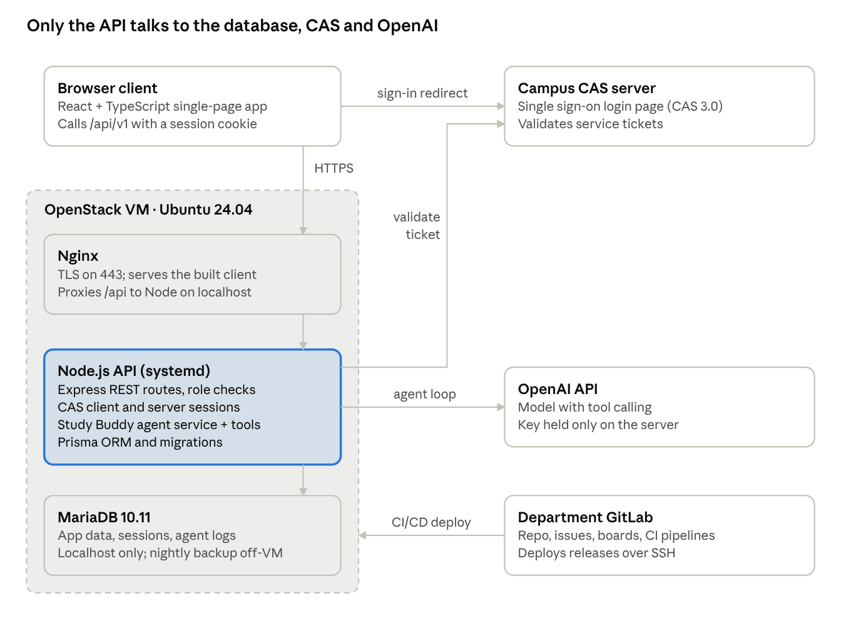
Image 1: application architecture · one VM, three external services
The API is the only trusted component: it enforces roles, validates CAS tickets server to server, runs the agent's tools under the signed-in user's permissions, and keeps the OpenAI key. Inside the API, code is layered as routes → services (business rules) → Prisma repositories, and the agent's tools call the same services as the REST routes, so permission rules live in one place.

3. Deployment on OpenStack
Environment | Where | Deployed by | Data
Local | Docker Compose: MariaDB, API, client, CAS mock | Developer | Synthetic seed data
Staging | VM studycircle-stg (2 vCPU, 4 GB RAM, 40 GB) | Every merge to main | Synthetic data
Production | VM studycircle-prod (2 vCPU, 4 GB RAM, 40 GB + backup volume) | Tagged release, manual approval job | Real users

- Network: one floating IP and DNS name per VM. Security group allows 443 and 80 (redirects to 443) from anywhere and 22 only from the campus VPN range.
- Nginx: terminates TLS; serves the built client from /var/www/studycircle; proxies /api/ to 127.0.0.1:3000; sets security headers (HSTS, CSP, X-Content-Type-Options); disables response buffering for the agent's streaming endpoint.
- API service: studycircle-api.service under systemd as an unprivileged user; restarts on failure; logs to journald.
- Configuration: environment file /etc/studycircle/api.env (mode 600) — DATABASE_URL, SESSION_SECRET, CAS_BASE_URL, CAS_SERVICE_URL, OPENAI_API_KEY, OPENAI_MODEL, AGENT_DAILY_LIMIT, AGENT_MONTHLY_TOKEN_CAP. Values come from GitLab CI/CD masked variables; never committed.
- Database: MariaDB on the same VM, bound to localhost only; app user has rights on the studycircle schema only.
- Deploy steps (CI job): build client and API → copy artifacts over SSH → prisma migrate deploy → restart service → hit /api/v1/health; on failure, switch the current symlink back to the previous release.
- Backups: nightly mariadb-dump compressed, kept 14 days on a separate Cinder volume and copied to object storage; restore drill on staging each release.

4. CAS sign-in flow
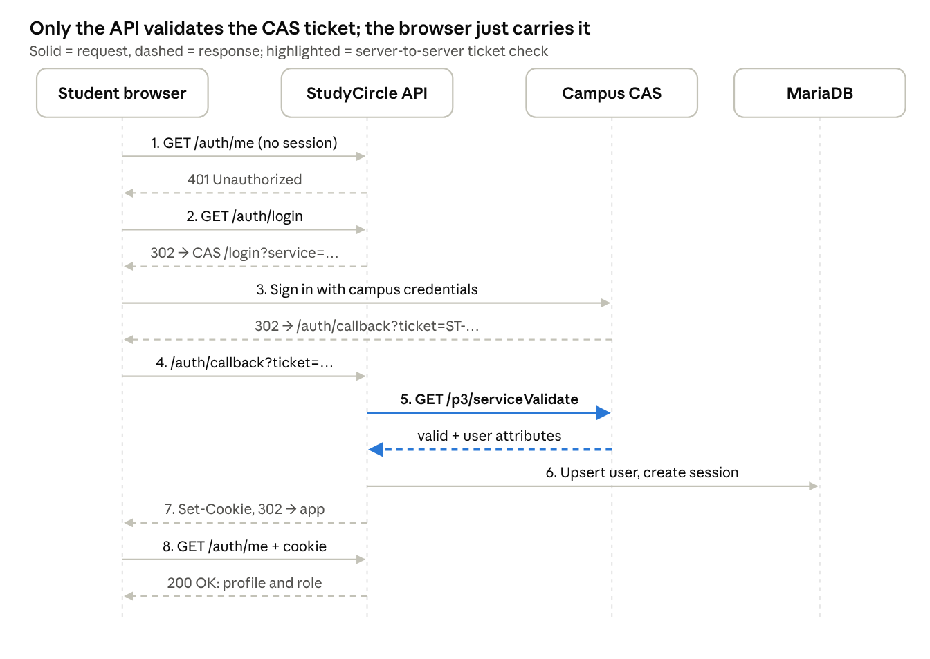
Image 2: CAS sign-in sequence · 8 steps
The ticket is validated server to server and used once. The session cookie is HttpOnly, Secure, SameSite=Lax; state-changing requests also carry a CSRF token. Sign-out destroys the session and redirects to CAS /logout.

5. Study Buddy agent design
Study Buddy is a server-side agent loop: the API sends the conversation and a fixed list of tools to OpenAI; the model asks for tool calls; the API runs each tool as the signed-in user with normal permission checks and returns the results; this repeats until the model answers (maximum 6 steps per turn). Write actions are never executed by the loop — they become proposals the user approves.
Tool | Type | What it does | Authorization
list_my_courses | Read | Courses the user is enrolled in | Own data only
search_groups | Read | Open groups matching course, mode, keywords | Enrolled courses only
get_group | Read | Group details and upcoming sessions | Same rules as GET /groups/{id}
get_my_availability | Read | User's weekly free slots | Own data only
find_common_times | Read | Top time slots where most group members are free (counts only, no names) | Group members only
draft_agenda | Read | Returns a timed agenda from topics the user gives | No data access
request_join_group | Write → proposal | Proposes joining a group | Executed only after user approves; then same rules as POST /groups/{id}/memberships
create_session | Write → proposal | Proposes a session with time, place, agenda | Executed only after approval; user must be a member
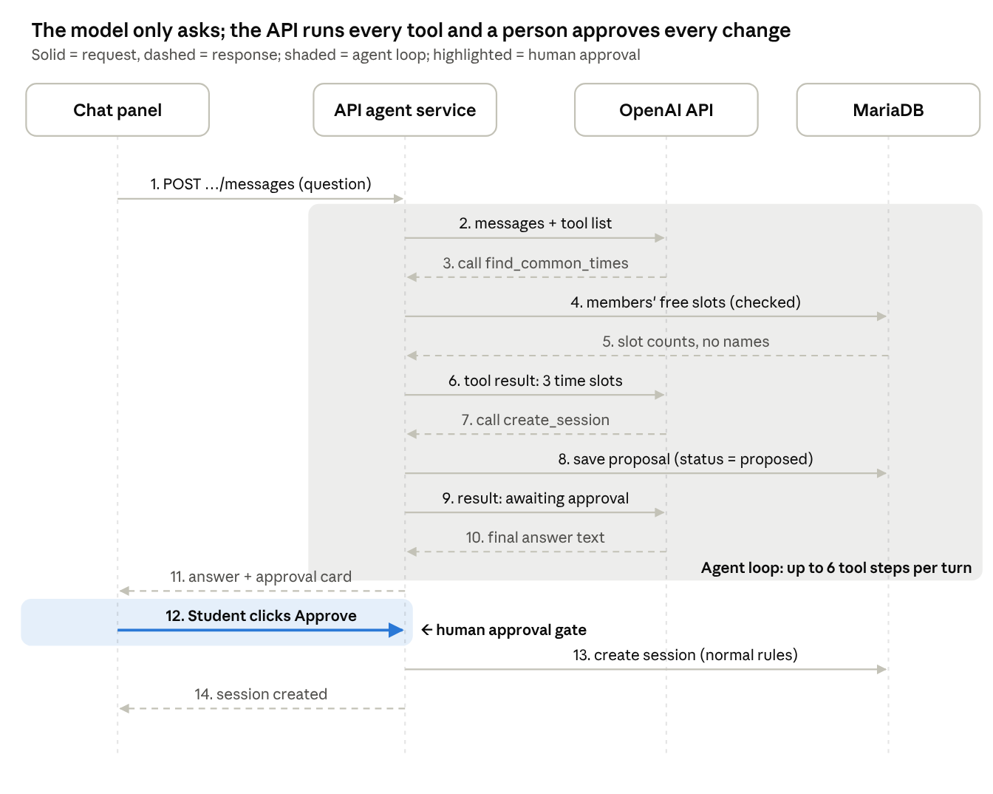
Image 3: Study Buddy agent sequence · 14 steps, 1 approval gate

Guardrails: tool allow-list only; every tool re-checks permissions; user-written text (group descriptions, agendas) is passed to the model as quoted data, never as instructions; no student IDs, grades or emails are sent to OpenAI; per-user daily message limit and a monthly token cap; every run, message and tool call is logged with token counts; proposals expire after 24 hours; the UI labels responses as AI-generated.

6. Data model (ERD)
Stored on a shared drive: StudyCircle_ERD
All tables use InnoDB, utf8mb4, and UTC timestamps. Key indexes: users.cas_username (unique), study_groups(course_id, status), study_sessions(group_id, starts_at), agent_messages(conversation_id, created_at), agent_tool_calls(status, created_at). The session store adds one sessions table managed by the library.
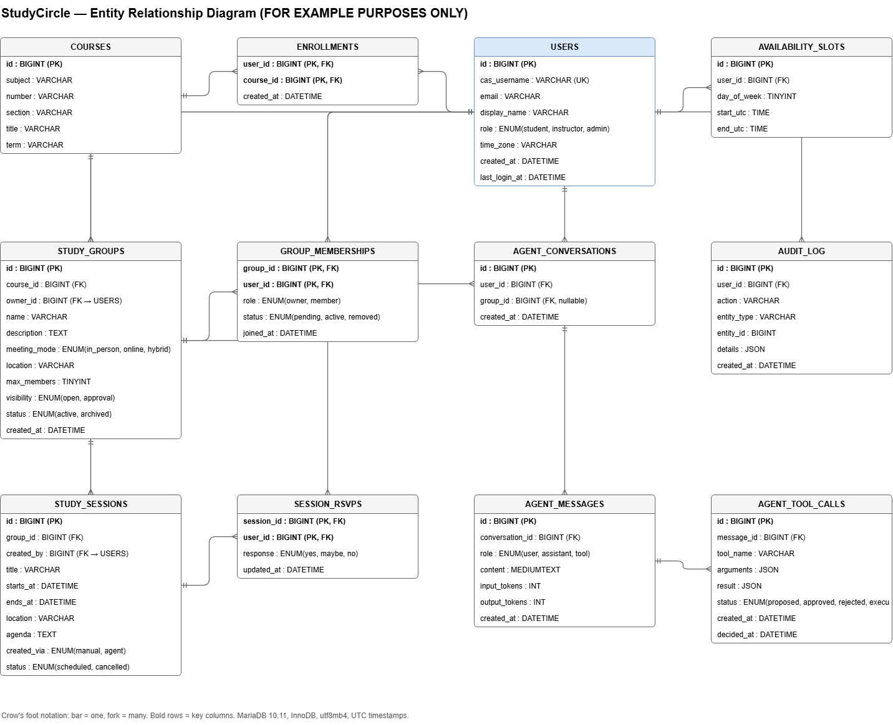
Image 4: ERD

7. API endpoints
Base path /api/v1. JSON in and out; errors as { "error": { "code", "message" } }. All endpoints except /health and the auth redirects need a valid session. The full contract lives in api/openapi.yaml.

Method | Path | Purpose | Who | Story
GET | /health | API and database status | Public | SC-07
GET | /auth/login | Redirect to CAS sign-in | Public | SC-10
GET | /auth/callback?ticket= | Validate CAS ticket, start session | Public | SC-10
GET | /auth/me | Current user and role | Signed in | SC-10
POST | /auth/logout | End session, redirect to CAS logout | Signed in | SC-11
GET | /courses?q=&term= | Search the course catalog | Signed in | SC-20
GET | /me/courses | My enrolled courses with open-group counts | Signed in | SC-21
POST | /courses/{courseId}/enrollment | Enroll me in a course | Student | SC-20
DELETE | /courses/{courseId}/enrollment | Unenroll me | Student | SC-20
GET | /groups?courseId=&mode=&open=&q=&page= | Search groups in my courses | Signed in | SC-31
POST | /groups | Create a group (creator becomes owner) | Enrolled student | SC-30
GET | /groups/{groupId} | Group details and upcoming sessions | Enrolled in course | SC-32
PATCH | /groups/{groupId} | Edit or archive a group | Owner | SC-36
GET | /groups/{groupId}/members | Members (names for members, counts for others) | Enrolled in course | SC-32
POST | /groups/{groupId}/memberships | Join or request to join | Enrolled student | SC-33
PATCH | /groups/{groupId}/memberships/{userId} | Approve or decline a request | Owner | SC-34
DELETE | /groups/{groupId}/memberships/{userId} | Leave, or remove a member | Self or owner | SC-34, SC-35
GET | /me/availability | My weekly availability | Signed in | SC-40
PUT | /me/availability | Replace my weekly availability | Signed in | SC-40
GET | /groups/{groupId}/sessions | Group's sessions | Member | SC-41
POST | /groups/{groupId}/sessions | Schedule a session | Member | SC-41
PATCH | /sessions/{sessionId} | Edit or cancel a session | Creator or owner | SC-41
PUT | /sessions/{sessionId}/rsvp | RSVP yes / maybe / no | Member | SC-42
GET | /me/sessions?days=14 | My upcoming sessions across groups | Signed in | SC-43
POST | /agent/conversations | Start a Study Buddy conversation | Signed in | SC-51
GET | /agent/conversations/{id} | Conversation history | Owner of conversation | SC-51
POST | /agent/conversations/{id}/messages | Send a message; streams the reply (Server-Sent Events) | Owner of conversation | SC-51
POST | /agent/actions/{toolCallId}/approve | Execute a proposed action | Owner of conversation | SC-55
POST | /agent/actions/{toolCallId}/reject | Discard a proposed action | Owner of conversation | SC-55
GET | /admin/users?q= | Search users | Admin | SC-60
PATCH | /admin/users/{userId} | Change a user's role | Admin | SC-60
GET | /admin/audit-log?action=&from=&to= | Audit log | Admin | SC-61
GET | /admin/agent-usage?from=&to= | Agent messages, tokens, estimated cost | Admin | SC-57

Example — create a group: POST /api/v1/groups with { "courseId": 412, "name": "Midterm 2 review", "meetingMode": "hybrid", "location": "Library 3rd floor / Webex", "maxMembers": 6, "visibility": "open" } → 201 Created with the group, or 422 with field errors.

8. Wireframes
Eight low-fidelity screens, numbered to match the backlog's design references: W1 Sign-in landing · W2 Dashboard · W3 Find groups · W4 Group detail · W5 Create group · W6 My availability · W7 Study Buddy panel with approval card · W8 Admin usage. They are on a separate design canvas.

9. Data sent to OpenAI
Data | Sent? | Notes
User's message text | Yes | Users are told not to enter personal information
Course codes and titles, group names and descriptions | Yes, when a tool returns them | Passed as quoted data
Free time slots and attendance counts | Yes | No names attached
Display names | First name only, when needed | e.g., owner of a recommended group
CAS username, email, student ID, grades | Never | Stripped by the tool layer

